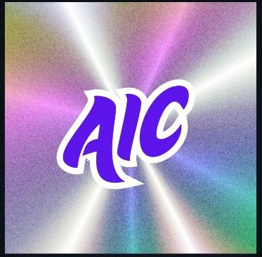

AI Marathon 2026
LLM Everywhere

ON
18th May 2026 - 6th June 2026
AT
Asia Pacific University
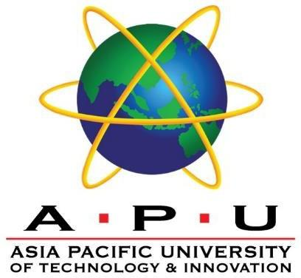
Organized By
APU AIC

Event Handbook

Table of Contents
Table of Contents 2
Introduction 3
Event Overview 4
Key Dates & Timeline 5
Event Activities 6
Event Workshops 7
Hackathon Challenge 8
Rules & Regulations 9
Eligibility 9
Participation 9
AI Usage Requirement 9
Technical Stack 9
Awards 9
Liability 10
Data Protection and Privacy 10
Intellectual Property 10
Judging Criteria 11
Submission Guidelines 13
Awards & Recognition 14
Contact Information 15

Introduction
Welcome to AI Marathon 2026!
Organized by the Artificial Intelligence Club (AIC) at Asia Pacific University (APU), AI Marathon is an exciting event designed for students who are interested in exploring the world of Artificial Intelligence. With the theme “LLM Everywhere,” the event highlights how Large Language Models are transforming industries and creating new opportunities for innovation.
Throughout the AI Marathon, participants will take part in expert talks, hands-on workshops, interactive sessions, and a hackathon challenge where teams work together to develop creative AI solutions for real-world problems.
Whether you are new to AI or already experienced, this event is a great opportunity to learn, collaborate, and build something meaningful together.
We’re excited to see the ideas and solutions you will create — let’s build the future of AI together!

Event Overview
AI Marathon 2026 is a multi-day technology event organized by the Artificial Intelligence Club (AIC) at Asia Pacific University (APU). The event brings together students, industry experts, and AI enthusiasts to explore the practical applications of Artificial Intelligence.
With the theme “LLM Everywhere,” AI Marathon focuses on how Large Language Models are transforming industries and enabling new AI-powered solutions. Participants will have the opportunity to attend expert talks, join hands-on technical workshops, and take part in interactive sessions designed to build both knowledge and practical skills.
The highlight of the event is the Hackathon Challenge, where participants work in teams to design innovative AI solutions for real-world problems. Teams will have a chance to present their ideas during the final pitching session.
AI Marathon aims to create a collaborative environment where students can learn new technologies, build innovative ideas, and connect with the AI community.

Key Dates & Timeline
Event Timeline | Date
Workshop Day 1 | 18th May 2026
Workshop Day 2 | 20th May 2026
Workshop Day 3 | 21st May 2026
Workshop Session by AIC RnD and Problem Statement Reveal | 22nd May 2026
Final Project Submission | 26th May 2026
Workshop Day 4 | 25th May 2026
Workshop Day 5 | 26th May 2026
Workshop Day 6 | 28th May 2026
Finalist Announcement | 1st June 2026
Hackathon Top 10 Finals Pitching | 6th June 2026

Event Activities
The following activities will be conducted during AI Marathon @ APU, designed to provide participants with both theoretical knowledge and practical exposure to Large Language Models (LLMs) under the theme “AI Marathon 2026: LLM Everywhere”.
Activity | Description | Target Skill Level
Talks & Knowledge Sharing Sessions | Expert-led talks exploring real-world applications of LLMs across industries:  - LLM in Manufacturing: Smarter Automation” “Shaping the Next Cloud with LLMs  - LLM in Finance: From Crypto to Compliance  - Language Models is the new Medical Assistant  - Scaling Your Conversation through LLMs  Learning Outcomes:  - Understand industry applications of LLMs.  - Identify opportunities for real-world solutions. | Beginner  -  Intermediate
Hands-on Technical Workshops | Guided coding sessions, demonstrations of LLM-powered tools, and applied problem-solving activities under the supervision of industry professionals and APU academics.  Learning Outcomes:  - Gain practical skills in building simple LLM-based solutions and workflows. | Intermediate  (Basic programming knowledge required)
Interactive Sessions | Activities such as Q&A sessions, panel discussions, quizzes, and audience challenges related to LLM topics, to encourage engagement with speakers and experts.  Learning Outcomes:  - Reinforce concepts from talks and workshops through discussion and interaction. | Beginner  -  Advanced  (open to all participants)

Event Workshops
Date | Time | Workshop | Host | Mode | Venue
18 May 2026 | 18:30 - 20:45 | What is DeAI & Why should you care? | Morpheus and APU DeAI Club | Physical | S-08-02
20 May 2026 | 13:30 - 15:30 | Introducing Chutes, Bittensor and How to Build on Chutes | Chutes.AI | Hybrid | TBC
21 May 2026 | 18:30 - 20:30 | Chutes and Agents: Creating Self Orchestrating Agents | Chutes.AI | Physical | S-08-02
22 May 2026 | 18:00 - 21:00 | Beyond the Scan: From X-Rays to Clinical Understanding with Multimodal LLM | AIC RnD | Hybrid | S-08-01
25 May 2026 | 18:30 - 20:45 | Hands-on Workshop with APU DeAI Club and Morpheus | Morpheus and APU DeAI Club | Physical | S-08-02
26 May 2026 | 13:30 - 15:30 | LLM in Cloud Computing | AWS APU Club | Physical | S-08-02
28 May 2026 | 10:30 - 12:30 | Transformers Explained:  Simple Explanation  of What's Behind the Black Box | Jeffry Christopher | Physical | S-08-01

Hackathon Challenge
The Hackathon Challenge serves as the core experiential component of AI Marathon, where participants apply knowledge gained from talks and workshops to develop innovative solutions using Large Language Models (LLMs).
Participants will collaborate in teams to design, prototype, and refine AI-powered solutions within a limited development period. The challenge problem statement will be revealed during the event, allowing teams to apply insights gained earlier in the programme.
Problem statements will reflect current industry trends and real-world applications of LLM technologies, encouraging participants to develop practical and impactful solutions.
At the end of the hackathon, all teams will submit their projects for evaluation. Top-performing teams will be selected as finalists and advance to the final pitching session, where they will present their solutions after further refinement if needed.

Rules & Regulations

Eligibility
- Open to students from any university who have registered for AI Marathon.
- Participation in talks and workshops is free.
- Workshops are intermediate-level, requiring basic programming knowledge; talks are beginner-friendly.
- Participation in the hackathon is optional and requires separate registration with a designated fee.
- Teams can include members from different institutions.

Participation
- Teams may consist of 1 to 4 members. Solo participation is welcome.
- Participants can choose their level of involvement in talks, workshops, or the hackathon.
- Teams must register before the deadline; team changes after registration are not permitted.
- All participants are expected to follow a code of conduct: harassment, discrimination, or disruptive behaviour may result in disqualification.

AI Usage Requirement
- All submissions must incorporate LLM & Agentic.
- Solutions must use AI meaningfully to enhance functionality, efficiency, or impact.

Technical Stack
- Teams may use any tools, frameworks, or APIs relevant to their solution.
- Effective integration of AI and other technologies will be highly valued.

Awards
- All prizes must be shared among team members as per their mutual agreement.
- Prizes are non-transferable and may only be claimed by the designated winner(s).
- The decisions of the judges and organizers regarding the selection of winners are final and binding, and no appeals, disputes, or reconsiderations will be accepted.

Liability
- Organizers reserve the right to modify rules without prior notice.
- Participants assume all risks related to participation.
- Organizers are not responsible for any damage, loss, or injuries.

Data Protection and Privacy
- Participant information will be kept secure and used only for event purposes unless consent is given.

Intellectual Property
- Participants retain IP rights to their projects.
- Teams grant organizers a non-exclusive, royalty-free license to showcase and promote projects for marketing and educational purposes.

Judging Criteria

Evaluation Criteria Distribution

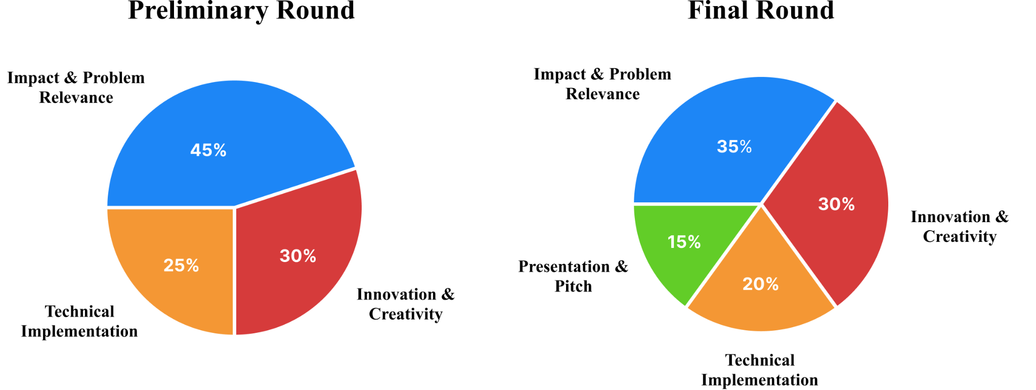

Evaluation Criteria Breakdown for Preliminary Round
Detailed Judging Rubrics for Final Round

CATEGORY A: IMPACT & PROBLEM RELEVANCE (45%)
MAX POINTS | CATEGORIES
20 POINTS | Track Understanding & Completeness
- Does the team demonstrate a good understanding of their chosen track’s objective?
- Does the solution cover the main tasks requested in the problem statement?
- Does the agent produce meaningful outputs

15 POINTS | Solution Effectiveness
- Does the proposed solution effectively address the identified problem?
- Is the approach logical and well-justified?
10 POINTS | Scalability & Future Potential
- Can the solution be scaled or expanded beyond the hackathon prototype?
- Does the team demonstrate future potential or practical deployment?

CATEGORY B: INNOVATION & CREATIVITY (30%)
MAX POINTS | CATEGORIES
20 POINTS | Originality of Idea
- How unique or creative is the solution?
- Does it introduce new approaches or perspectives in solving the problem?

10 POINTS | Tool Use & AI Orchestration
- Are external tools creatively integrated into the logic?
- Does the technology enhance the uniqueness of the solution?

CATEGORY C: TECHNICAL IMPLEMENTATION (25%)
MAX POINTS | CATEGORIES
15 POINTS | Agentic Architecture & Design
- Does the team describe a clear agentic architecture?
- Are the components of the solution logically structured?

10 POINTS | Prototype Functionality
- Has the team built a working prototype or proof of concept?
- Does the prototype demonstrate the core functionality of the solution?

Submission Guidelines
- The submitted solution must reflect the team’s original work, completed during the hackathon duration.
- Solutions must leverage LLM or AI technology in addressing the problem statement.
- Plagiarism of ideas, code, or designs is strictly prohibited.
- Submissions must be made before the deadline; incomplete, illegible, or late submissions will not be considered.
- Submissions with offensive, illegal, or unethical content will result in immediate disqualification.

Submission Details

Phase 1: Preliminary Round Requirements
- Pitch Deck (Max 10 Slides)
  - A concise presentation outlining your problem statement, solution architecture, business value, and team composition.
  - Excluding title and thank you slides.
- Agent Framework Diagram
  - Included directly within your Pitch Deck.
  - Must clearly map out and visualize your agent workflow.
- Video Demo (3–4 Minutes)
  - A recorded walkthrough of your working solution.
  - Focus on demonstrating the user experience and the underlying AI capabilities.
- Source Code & Documentation
  - A link to your public or shared repository.
  - Must include a proper README.md file explaining:
    - System requirements and dependencies.
    - Clear, step-by-step instructions on how to install, configure, and run the application locally.

Phase 2: Grand Final Requirements
- Enhanced Project
  - Refined and improved source code incorporating feedback from the preliminary round.
- Final Pitch Deck
  - An updated, highly polished version of your pitch deck optimized for a live presentation to the grand panel of judges.

Awards & Recognition
- Certificate of Participation will be awarded to all participants who register under a team and successfully submit their project.
- Cash prizes will be awarded to the top three teams from a total prize pool of RM3,000:
First Place : RM 1,250
Second Place : RM 750
Third Place : RM 500
Special Price : RM 500
- Finalist teams will receive exclusive AI Marathon finalist merchandise, including custom event T-shirts and sponsored tech accessories.
- Hackathon participants will also receive AI Marathon branded items such as drawstring bags, lanyards, and stickers featuring AIC and sponsor logos as event memorabilia.

Contact Information
Tan Wai Ken (AIC President)
Phone: +60 19-8876422
Email: tanwaiken552@gmail.com

Harry Angdreas (People Relations Team)
Phone: +60 11-12403599
Email: harryangdreasang@gmail.com

Gerrend Alfredo (Event Manager)
Phone: +60 16-6499001
Email: gerrend13@gmail.com

